MODULE 4 – INTRODUCTION TO DBMS
LAB EXERCISES

1. Introduction To SQL
Lab 1.
Create a database called library_db and s table books with columns – book_id, title, author, publisher, year_of_publication, and price. Insert five records into the table.
Ans.
Create database
1. CREATE DATABASE library_db;
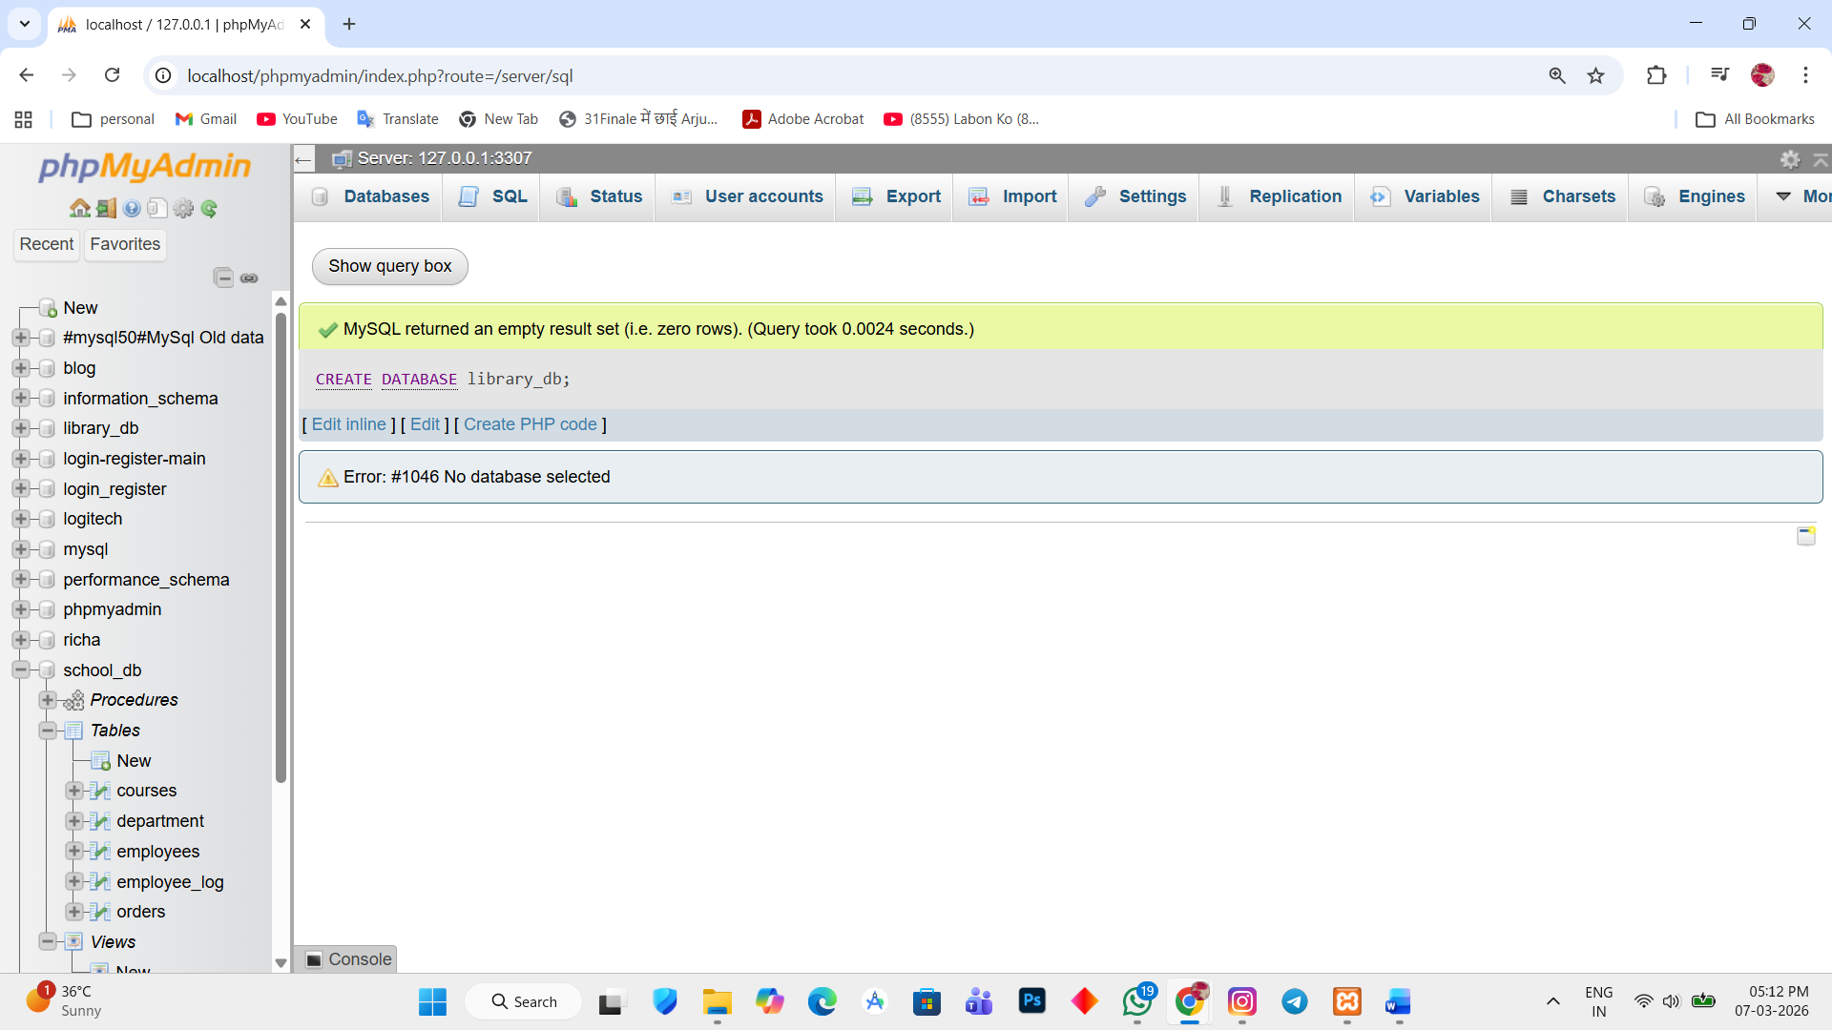

Create book table
2. CREATE TABLE books (book_id int PRIMARY KEY, title varchar(255), author varchar(255), publisher varchar(255), year_of_publicatino int , price int);
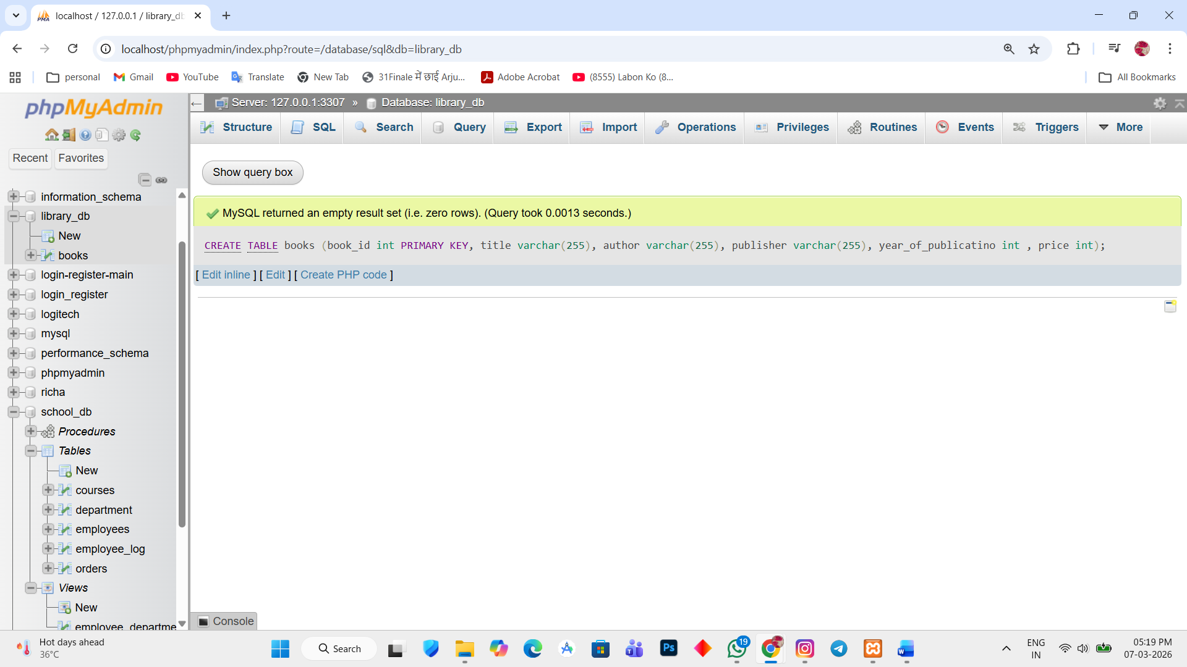

Insert five records
3. INSERT INTO books (book_id, title, author, publisher, year_of_publicatino, price) VALUES
(1, 'Database Sysy=tem', 'Rciha', 'McGraw Hill', 2019, 500),
(2, 'Operating System', 'Kavya', 'Wiley', 2018, 650),
(3, 'Computer Network', 'Jiyan', 'Mithon', 2020, 450),
(4, 'Sofware Engineering', 'Pearson', 'Macron', 2021, 800);

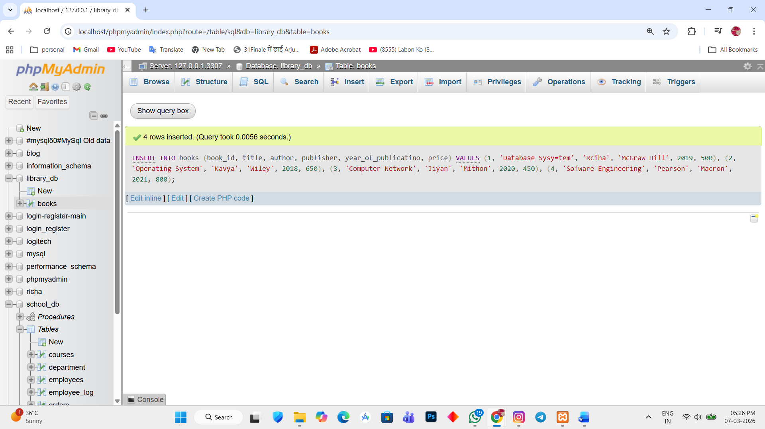

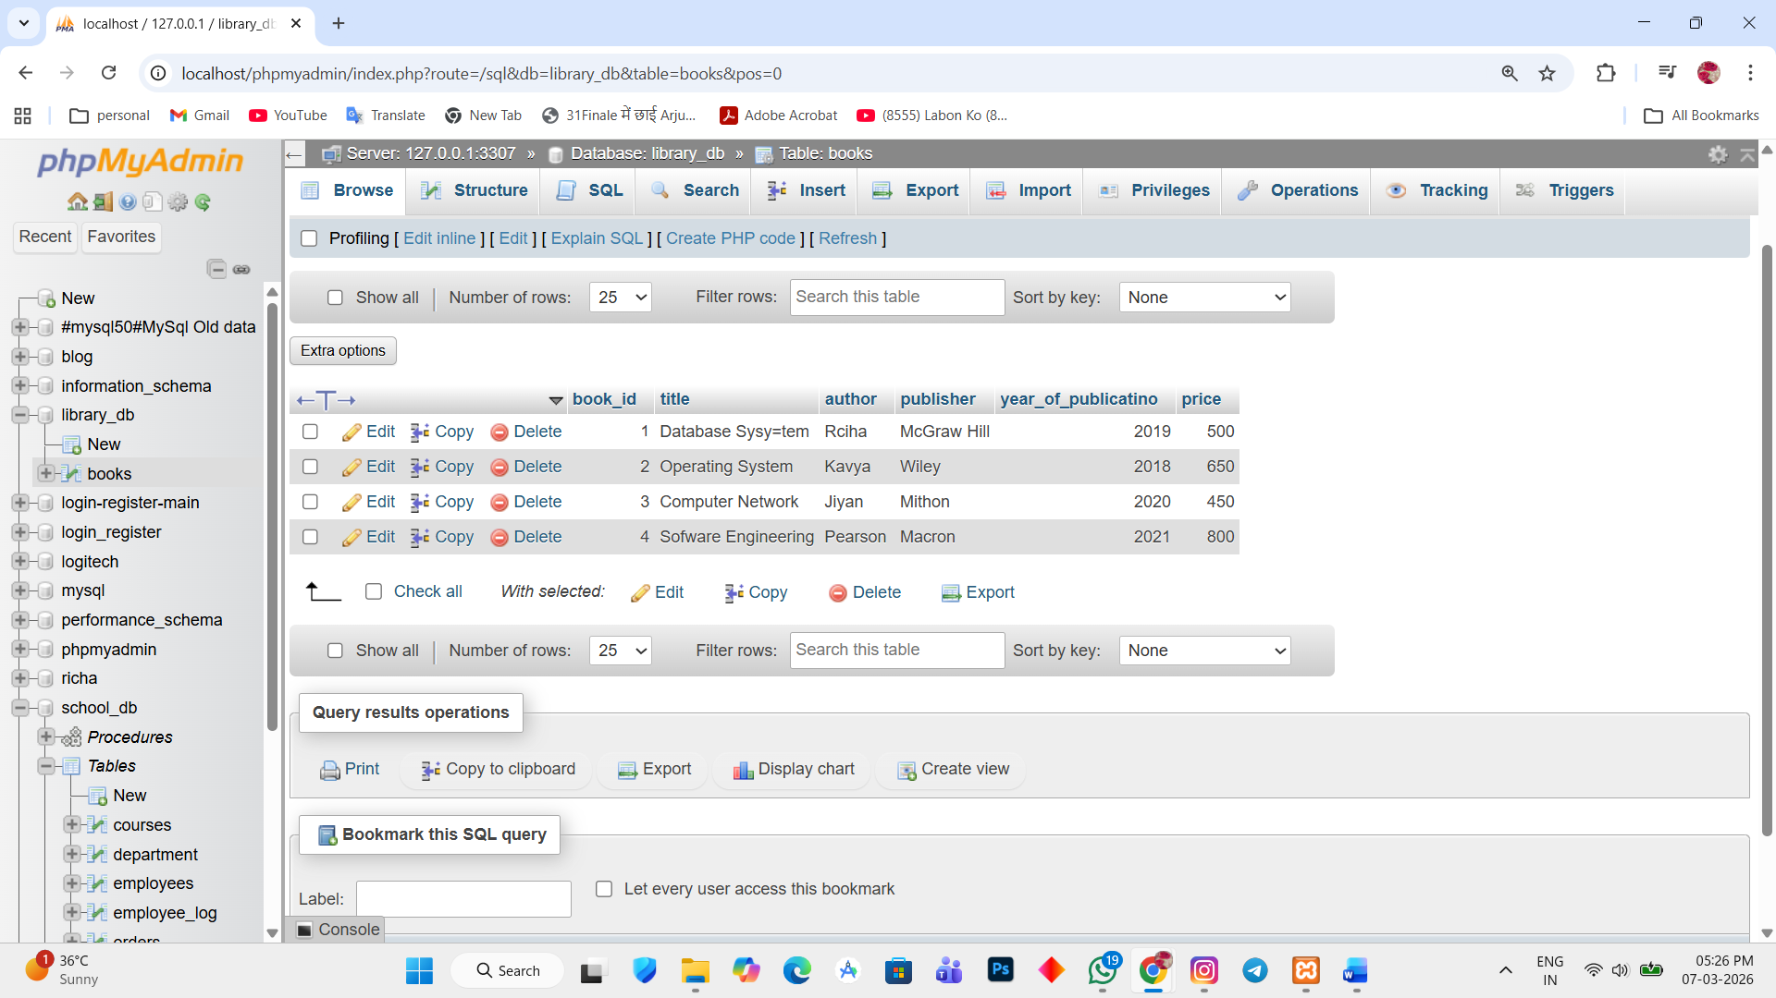

Lab 2.
Create a table members in library_db with columns – member_id, member_name, date_of_membership, and email. Insert five records into this table.
Ans.
Create member table:
1. CREATE TABLE members(member_id int PRIMARY KEY, member_name varchar(255), date_of_membership DATE, email varchar(255));

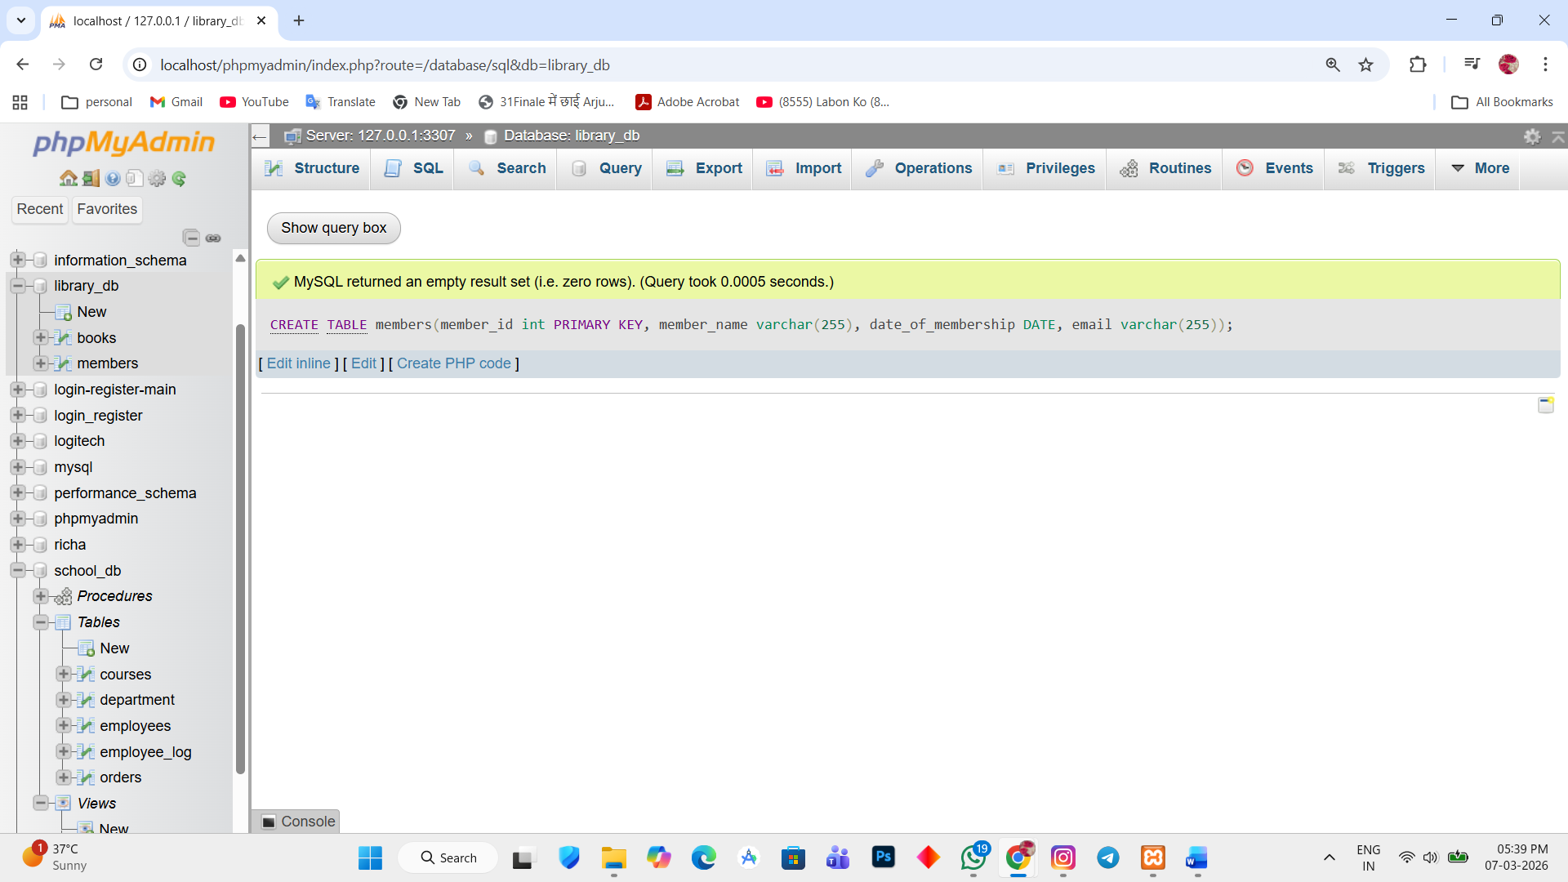

Insert records
2. INSERT INTO members VALUES (1, 'Richa Parmar', '2023-01-10', 'richa@gmail.com'),
(2, 'Purvi Rathod', '2023-02-15', 'purvi@gmail.com'),(3, 'Jatin Rathod', '2023-03-20', 'jatin@gmail.com'),
(4, 'Vaibhav Ahir', '2023-04-05', 'vaibhav@gmail.com'), (5, 'Hardik Vala', '2023-05-12', 'hardik@gmail.com');
